LAB 5 python libraries

**Class Task:**

1. **Write a Python program to get the number of occurrences of a specified element in an array.**

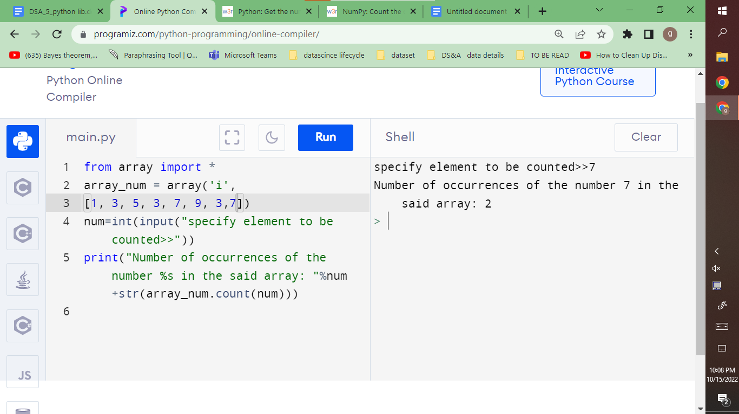

**Another way :**

import numpy as np

nums = np.array([10, 20, 20, 20, 20, 0, 20, 30, 30, ])

print("Original array:")

print(nums)

print(np.count_nonzero(nums == 20))

1. **Write a NumPy program to reverse the order of elements in an array (first element should become the last element)**

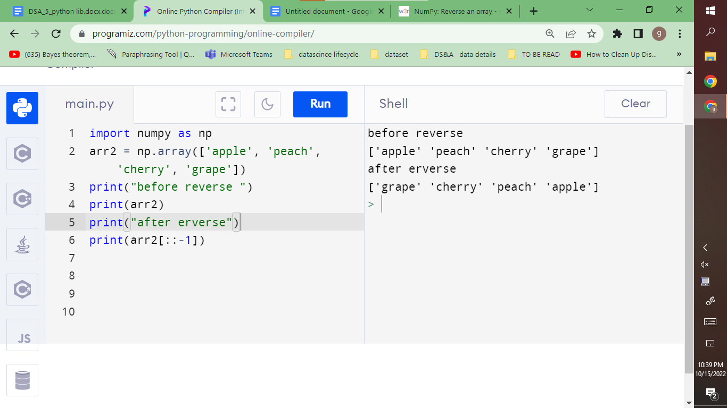

1. **Perform all the included operations on the dataset of your own choice and plot histogram or pie chart of each task using matplotlib library**

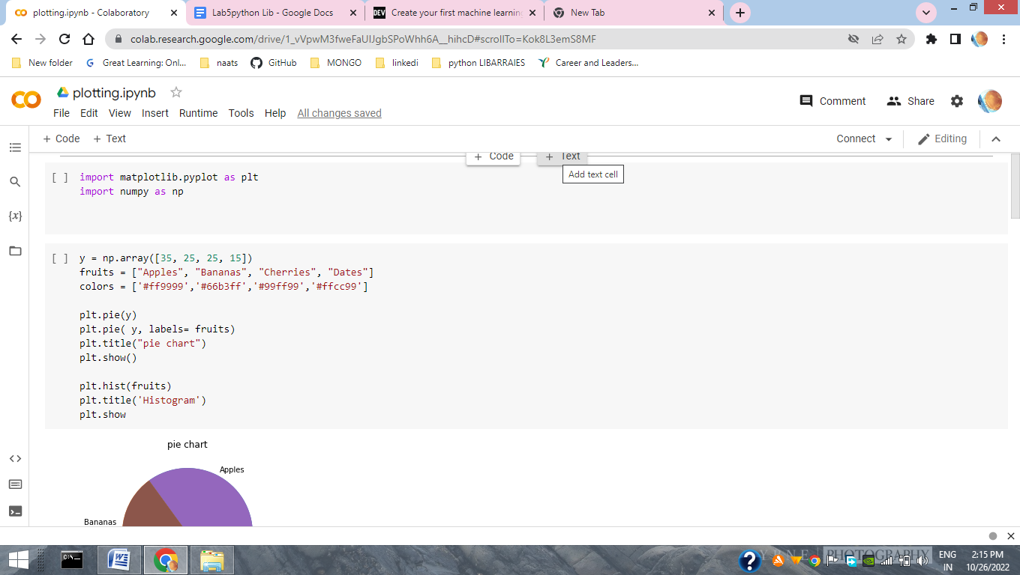

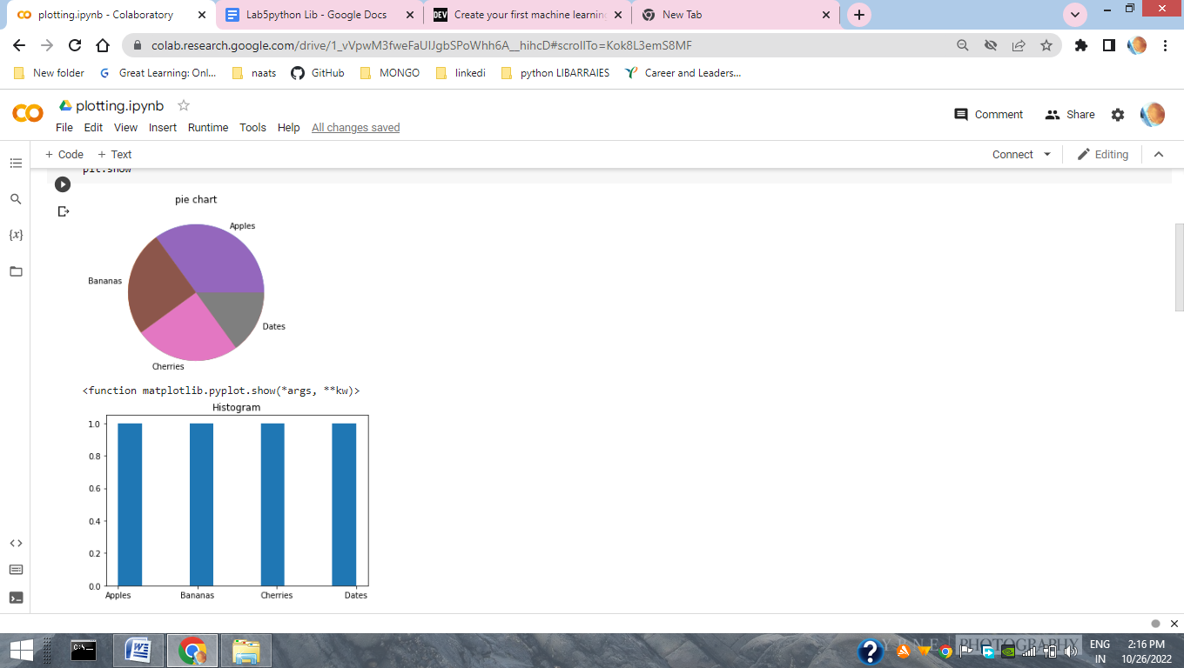

**#negative slicing**

**print(y)**

**print("Negative Slicing \n",y[-3:-1])**

**z=y[-3:-1]**

**plt.pie(z)**

**plt.show()**

**plt.hist(z)**

**Plt.show**

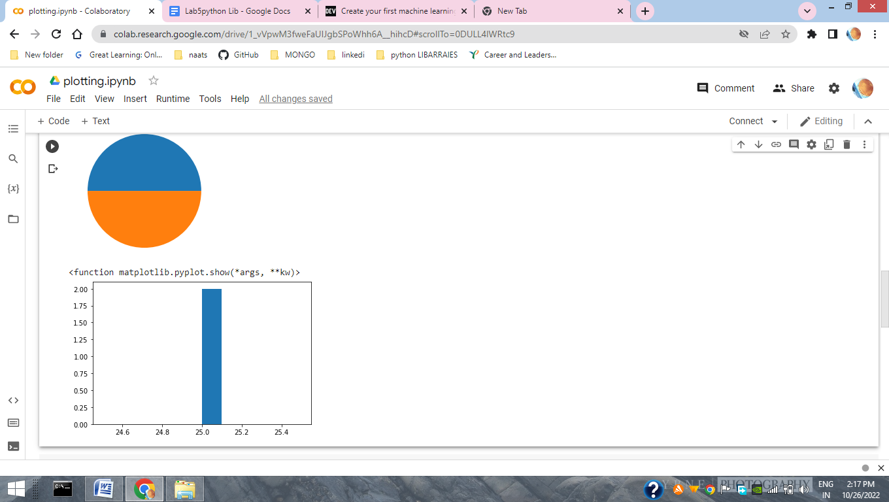

**Output:**

**[35 25 25 15]**

**Negative Slicing**

**[25 25]**

1. **Write a Python program to plot a data of your choice using Matplotlib**

import matplotlib.pyplot as plt

# creating data points to plot

X = [590,540,740,130,810,300,320,230,470,620,770,250]

Y = [32,36,39,52,61,72,77,75,68,57,48,48]

# customizing scatter plot

plt.scatter(X, Y, s=60, c='red', marker='^')

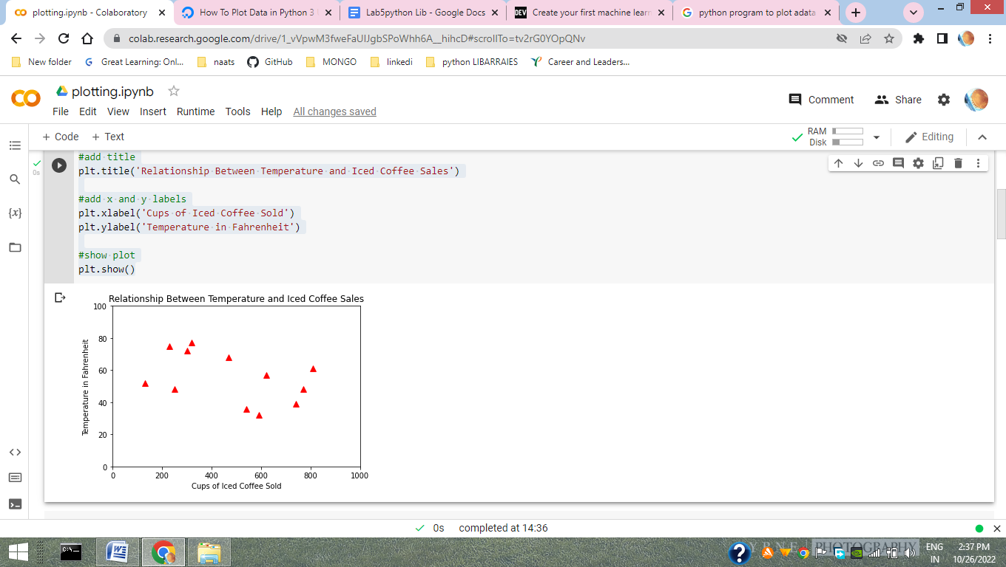

#change axes ranges

plt.xlim(0,1000)

plt.ylim(0,100)

#add title

plt.title('Relationship Between Temperature and Iced Coffee Sales')

#add x and y labels

plt.xlabel('Cups of Iced Coffee Sold')

plt.ylabel('Temperature in Fahrenheit')

#show plot

plt.show()

1. **Import dataset “Iris” and “mtcars” and plot a histogram on any of the desired dataframe.**

**import pandas as pd**

**cols = ['sepal_length', ' sepal_width', 'petal_length', 'petal_width', 'class']**

**df = pd.read_csv('https://archive.ics.uci.edu/ml/machine-learning-databases/iris/iris.data', names=cols)**

**df.head()**

**x = df["sepal_length"]**

**y=df['class']**

**import matplotlib.pyplot as plt**

**plt.hist(x, bins = 20, color = "pink")**

**plt.hist(y, bins = 20, color = "yellow")**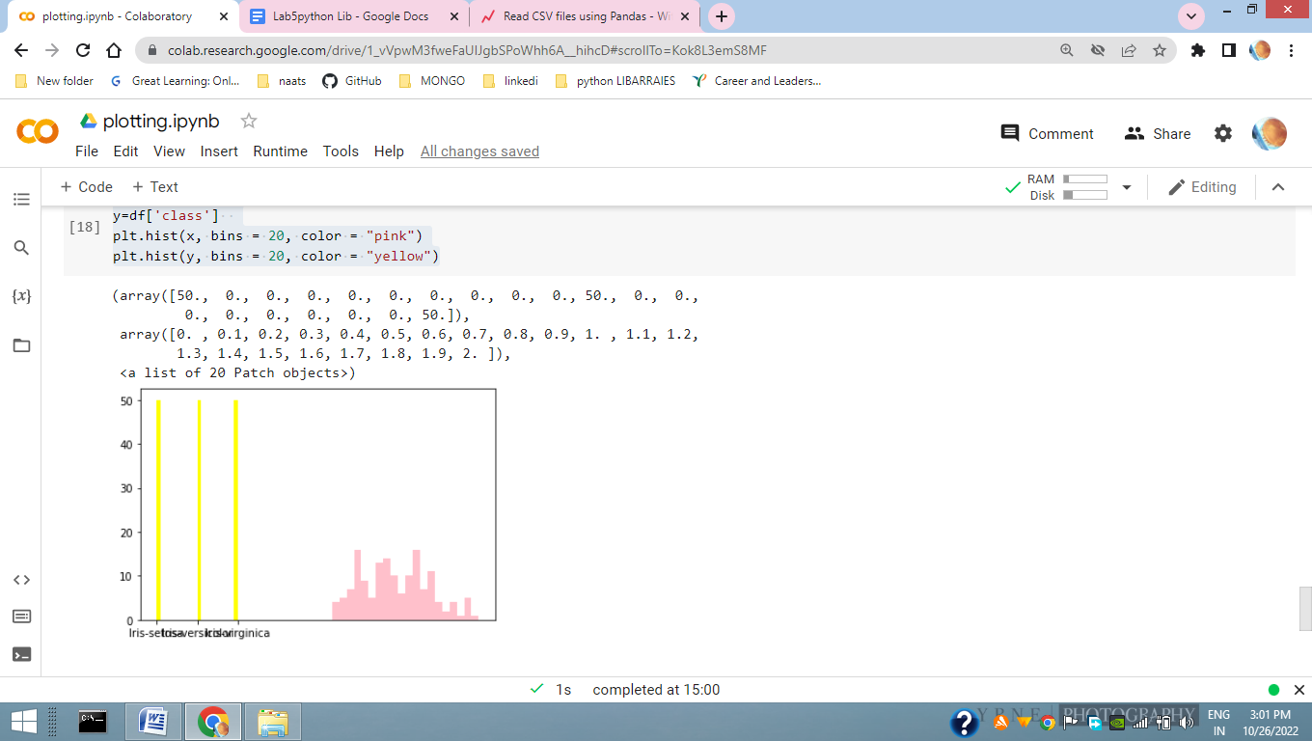

**import dataset “mtcars”**

